 Hi there!

 Was training some ways to simulate animal (or other organisms) movements having into account habitat suitability. To do this, I used my previous eWalk model as the underlying process to simulate random or directional walks. This model is based on Brownian / Ornstein–Uhlenbeck process. You can find [more about eWalk model here](http://allthiswasfield.blogspot.com.es/2016/11/ewolk-r-function-to-simulate-two.html)!

 Today, I will add one more element to this movement simulations. In this case, we will have into account the habitat or environmental preferences of the simulated species, to perform a simulation like this:

[](https://i0.wp.com/4.bp.blogspot.com/-l-bCOkGMWMw/Wui-894bmwI/AAAAAAAAAP4/nD5BRuZWLPAVt7t3Zh57dRr-t4CwmWMxACLcBGAs/s1600/paths.gif?ssl=1)

 First, we will create a raster layer as a random environmental variable, for example tree cover.

library (raster)   
 library (dismo)   
   
 tc <- raster(nrows=100, ncols=100, xmn=0, xmx=100, ymn=0,ymx=100)   
 tc[] <- runif(10000, -80, 180)   
 tc <- focal(tc, w=matrix(1, 5, 5), mean)   
 tc <- focal(tc, w=matrix(1, 5, 5), mean)   
 plot(tc)

[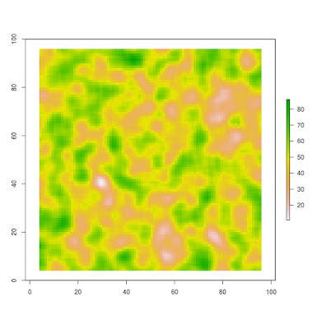](https://i2.wp.com/1.bp.blogspot.com/-Bb2edCESEEs/Wuivgcq5P6I/AAAAAAAAAO4/EjV9L9_ymSInc4gsxrXHQFBy3FVlqgiSwCLcBGAs/s1600/tc.png?ssl=1)

 Second, we will define the species class. The species will be defined by their position (coordinates), and their optimum for the environmental variable.

species <- setClass("species", slots=c(x="numeric", y="numeric", opt="numeric"))

 Here we will define the Red deer species as a specimen in the coordinates (50,50) and an optimum of 80 for the environmental variable (tree cover). In the same way, we will define the Egyptian mongoose as a specimen in the coordinates (50,50) and an optimum of 30 for the tree cover variable.

Red_deer <- species(x= 50, y =50, opt= 90)   
 Egyptian_mongoose <- species(x= 50, y =50, opt= 30)

 Now, we will load the “*go*” function (I do not have a name for it yet). It require a species (*sp*), a raster layer with any environmental variable (*env*), number of iterations (*n*), a Brownian motion parameter (that is, how random is the movement of your species), a geographical optimum (the wanted destination of your species *theta_x* and *theta_y*), and the attraction strength or “interest” of the species to get this position (*alpha_x* and *alpha_y*). The syntaxis should be something like this:

path <- go (sp, env, n, sigma, theta_x, alpha_x, theta_y, alpha_y)

 Here is the function to load (I will comment the function in a future post):

go <- function (sp, env, n, sigma, theta_x, alpha_x, theta_y, alpha_y) {   
 track <- data.frame()   
 track[1,1] <- sp@x   
 track[1,2] <- sp@y   
 for (step in 2:n) {   
 neig <- adjacent(env,   
 cellFromXY(env, matrix(c(track[step-1,1],   
 track[step-1,2]), 1,2)),   
 directions=8, pairs=FALSE )   
 options <- data.frame()   
 for (i in 1:length(neig)){   
 options[i,1]<-neig[i]   
 options[i,2]<- sp@opt - env[neig[i]]   
 }   
 option <- c(options[abs(na.omit(options$V2)) == min(abs(na.omit(options$V2))), 1 ],   
 options[abs(na.omit(options$V2)) == min(abs(na.omit(options$V2))), 1 ])   
 new_cell <- sample(option,1)   
 new_coords <- xyFromCell(env,new_cell)   
 lon_candidate<--9999   
 lat_candidate<--9999   
   
 while ( [is.na](http://is.na)(extract(env, matrix(c(lon_candidate,lat_candidate),1,2)))) {   
 lon_candidate <- new_coords[1]+ (sigma * rnorm(1)) + (alpha_x * ( theta_x - new_coords[1]))   
 lat_candidate <- new_coords[2]+ (sigma * rnorm(1)) + (alpha_y * ( theta_y - new_coords[2]))   
 }   
 track[step,1] <- lon_candidate   
 track[step,2] <- lat_candidate   
 }   
 return(track)   
 }

 Well, now we can perform a simple experiment with our two specimens. We will simulate random movement of these two species having into account their environmental optimums. The “*go*” function will return us the track or the path followed by each specimen (coordinates by each step).

deer_simul <- go (Red_deer, tc, 100, 2, 90, 0, 90, 0)   
 mongoose_simul <- go (Egyptian_mongoose, tc, 100, 2, 90, 0, 90, 0)

 We can plot the paths…

plot(tc)   
 lines(deer_simul, lwd=1.5, col="red")   
 points(deer_simul, cex=0.3, col="red")   
 lines(mongoose_simul, lwd=1.5, col="blue")   
 points(mongoose_simul, cex=0.3, col="blue")   
 legend("topleft", legend=c("deer","mongoose"), col=c("red","blue"),   
 lty=c(1,1), lwd=c(2,2))

[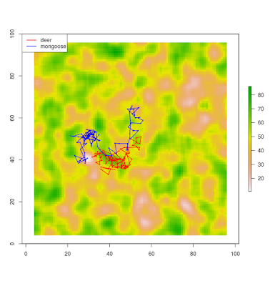](https://i0.wp.com/1.bp.blogspot.com/-e1lO1DOhrrg/Wui2udjjlDI/AAAAAAAAAPY/BJhOCFDPT4YvPDhk66RUCWmwcB2R2PT3wCLcBGAs/s1600/paths.png?ssl=1)

 To test if each species is actually “searching” their environmental optimum, we can extract the environmental values by step for each species and plot their density distributions.

plot(density(extract(tc, deer_simul)),lwd=3, col="red", xlim=c(20,80),   
 ylim=c(0,max(c(density(extract(tc, deer_simul))$y,   
 density(extract(tc, mongoose_simul))$y))),   
 main="locations density distribution", xlab="tree cover")   
 lines(density(extract(tc, mongoose_simul)),lwd=3, col="blue")   
 legend("topleft", legend=c("deer","mongoose"), col=c("red","blue"),   
 lty=c(1,1), lwd=c(3,3))

[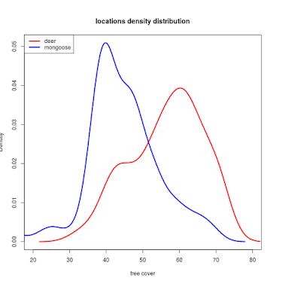](https://i0.wp.com/2.bp.blogspot.com/-uDp2lf-lA_w/Wui3gvsGFMI/AAAAAAAAAPg/J9Fy7Z9TUpYUk0SMSuACEmafnJJui_T6QCLcBGAs/s1600/Rplot.png?ssl=1)

 So, we can see that the deer is actually using patches with a higher value of tree cover than the mongoose… our simulation worked!